1st Screen – FP Set-Up…….
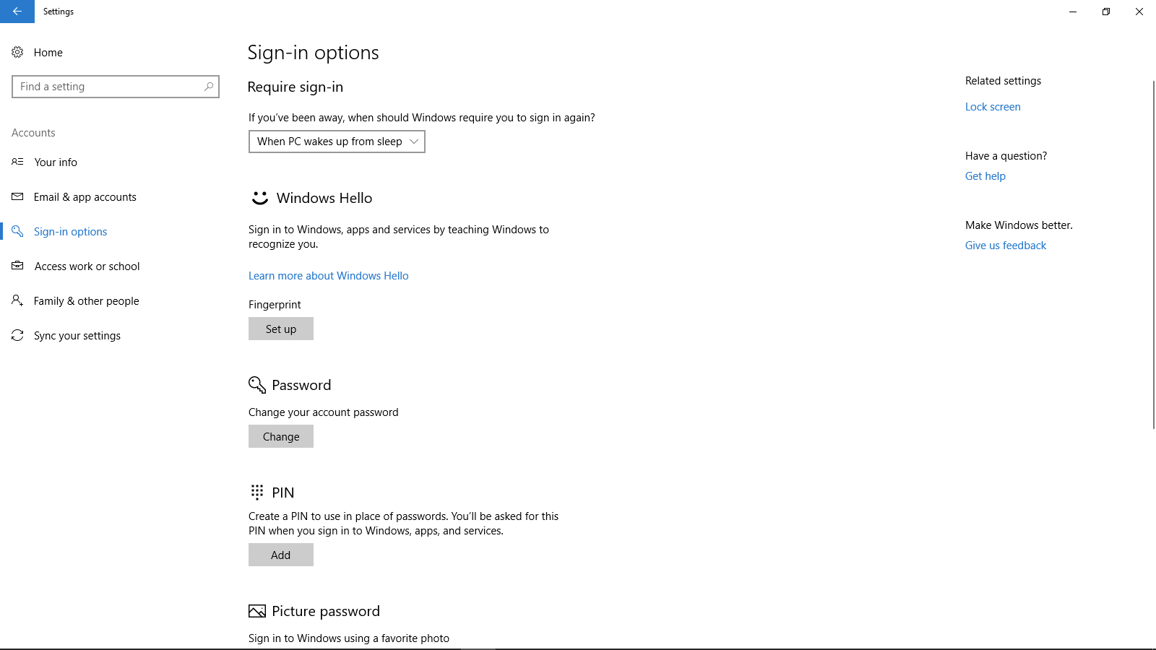

2nd Screen – Welcome to Windows……Get Started…
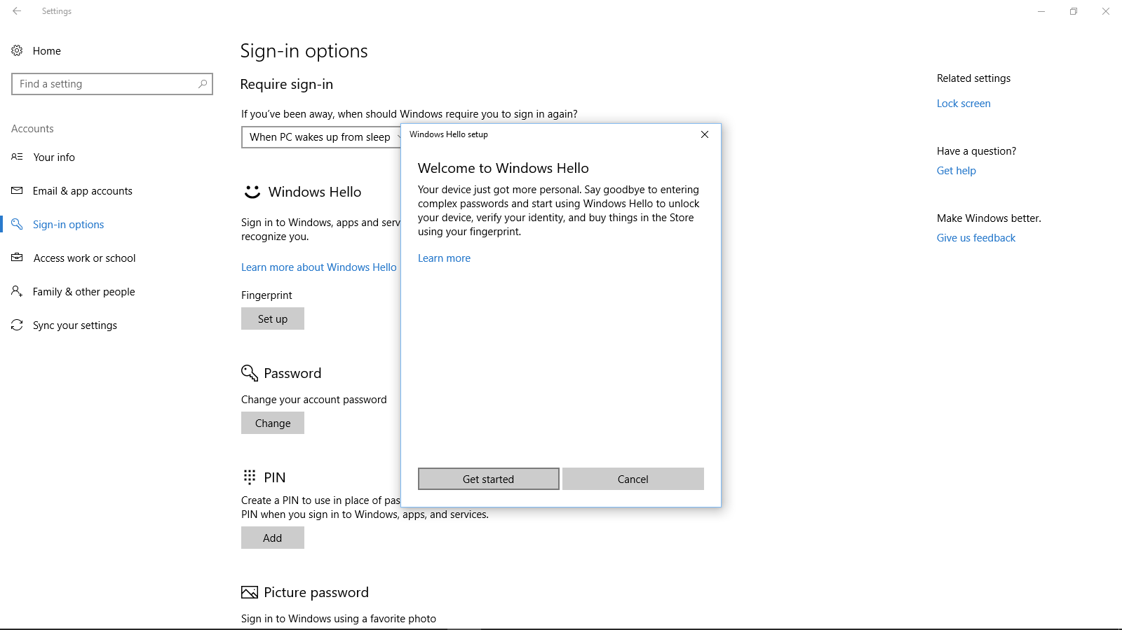

3rd Screen - ????? Nothing happens……….???? I don’t see a scanner option and scanner not flashing.

